Prof. Sweat

CS 4400

7/4/17

Team: Ben, Michael, Rob, Will

Below: EER Diagram, Schema Diagram, Create table SQL statements

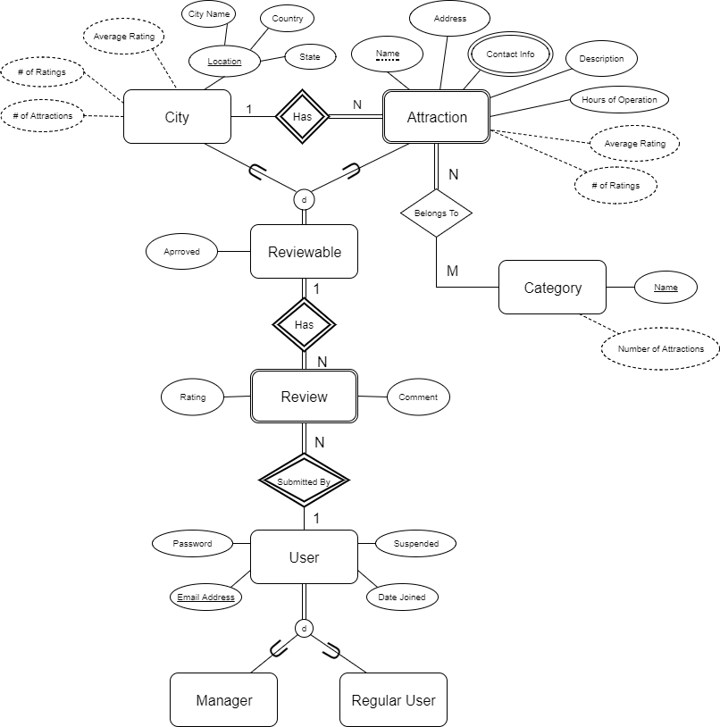

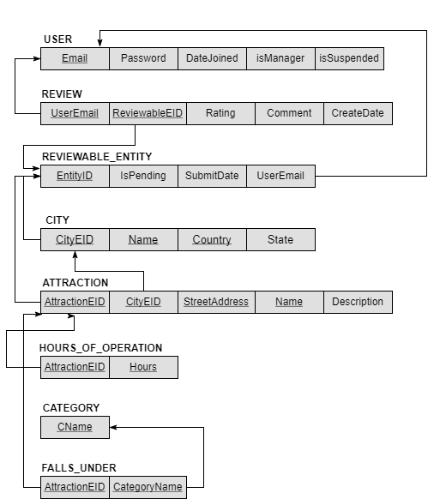

CREATE SCHEMA `RateACity` ;

CREATE TABLE `RateACity`.`USER` (

`Email` VARCHAR(45) NOT NULL,

`Password` INT NOT NULL,

`DateJoined` DATETIME NULL,

`IsManager` TINYINT(1) NOT NULL DEFAULT 0,

`IsSuspended` TINYINT(1) NOT NULL DEFAULT 0,

PRIMARY KEY (`Email`),

CHECK (Email IN('@', '.')) );

CREATE TABLE `RateACity`.`REVIEWABLE_ENTITY` (

`EntityID` INT NOT NULL,

`IsPending` TINYINT(1) NOT NULL DEFAULT 0,

`UserEmail` VARCHAR(45) NOT NULL,

`SubmitDate` DATETIME NOT NULL,

PRIMARY KEY (`EntityID`),

FOREIGN KEY (`UserEmail`) REFERENCES `RateACity`.`USER` (`Email`) ON UPDATE CASCADE,

CHECK (UserEmail IN('@', '.')) );

CREATE TABLE `RateACity`.`REVIEW` (

`UserEmail` VARCHAR(50) NOT NULL,

`ReviewableEID` INT NOT NULL UNIQUE,

`Rating` INT NOT NULL,

`Comment` VARCHAR(45) NOT NULL,

`CreateDate` DATETIME NOT NULL,

PRIMARY KEY (`UserEmail`, `ReviewableEID`),

FOREIGN KEY (`UserEmail`) REFERENCES `RateACity`.`USER` (`Email`) ON UPDATE CASCADE,

FOREIGN KEY (`ReviewableEID`) REFERENCES `RateACity`.`REVIEWABLE_ENTITY` (`EntityID`),

CHECK (Rating>0 AND Rating<6),

CHECK (UserEmail IN('@', '.')) );

CREATE TABLE `RateACity`.`CITY` (

`CityEID` INT NOT NULL,

`CityName` VARCHAR(45) NOT NULL,

`Country` VARCHAR(45) NOT NULL,

`State` VARCHAR(45) NULL,

PRIMARY KEY (`CityEID`),

FOREIGN KEY (`CityEID`) REFERENCES `RateACity`.`REVIEWABLE_ENTITY` (`EntityID`));

CREATE TABLE `RateACity`.`ATTRACTION` (

`AttractionEID` INT NOT NULL,

`CityEID` INT NOT NULL,

`StreetAddress` VARCHAR(45) NOT NULL,

`AttractionName` VARCHAR(45) NOT NULL,

`Description` VARCHAR(45) NOT NULL,

PRIMARY KEY (`AttractionEID`, `StreetAddress`),

FOREIGN KEY (`AttractionEID`) REFERENCES `RateACity`.`REVIEWABLE_ENTITY` (`EntityID`),

FOREIGN KEY (`AttractionEID`) REFERENCES `RateACity`.`CITY` (`CityEID`) );

CREATE TABLE `RateACity`.`HOURS_OF_OPERATION` (

`AttractionEID` INT NOT NULL,

`Hours` VARCHAR(45) NOT NULL,

PRIMARY KEY (`AttractionEID`, `Hours`),

FOREIGN KEY (`AttractionEID`) REFERENCES `RateACity`.`ATTRACTION` (`AttractionEID`) );

CREATE TABLE `RateACity`.`CATEGORY` (

`CName` VARCHAR(45) NOT NULL,

PRIMARY KEY (`CName`));

CREATE TABLE `RateACity`.`FALLS_UNDER` (

`AttractionEID` INT NOT NULL,

`CName` VARCHAR(45) NOT NULL,

PRIMARY KEY (`AttractionEID`, `CName`),

FOREIGN KEY (`AttractionEID`) REFERENCES `RateACity`.`ATTRACTION` (`AttractionEID`),

FOREIGN KEY (`CName`) REFERENCES `RateACity`.`CATEGORY` (`CName`) );